**Assignment-UI/UX**

**Hobby App**

**Aim:**

Create an app to help users discover and track their **hobbies**.

**Platform Steps:**

1. **Collect Information**: Research popular hobbies, trends, and user preferences.
2. **Create Canvas**: Design the app layout with sections for **Discover Hobbies**, **Track Progress**, and **Community**.
3. **Add Elements**: Use engaging visuals, hobby categories, and tracking features (e.g., to-do lists, goals).
4. **Build Features**: Implement **hobby discovery**, **progress tracking**, and **social sharing** options.
5. **Prototyping**: Develop an **interactive prototype** to test user experience and flow. 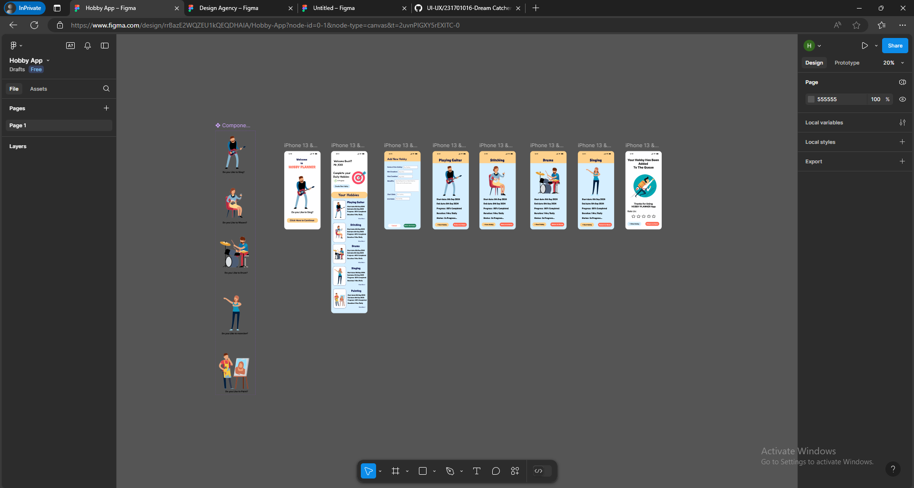

**Result:**

The **Hobby App** design is **created** and **verified**.